# Ocean Gate

DATA STORAGE PRODUCT

|  |
| --- |
| *2nd December 2025* |
| ***PREPARED BY***  *GHAZANFAR* |
|  |

|  |  |  |  |
| --- | --- | --- | --- |
| **S.no** | **Student id** | **Name** | **Email** |
| **1** | 1671043 | GHAZANFAR SHAHZAD | Ghazanfarshahzad1199@gmail.com |
| **2** | 1670774 | TALHA | Mrtalha511@gmail.com |
| **3** | 1669775 | FAREHA AKHTER | [A29904152@gmail.com](mailto:A29904152@gmail.com) |



Table of Contents

2nd December 2025

***PREPARED BY*** 1

*Ghazanfar shahzad* 1

This project is a sample website designed for OceanGate Limited, a company that manufactures data storage products.

The website helps customers view different products, learn their features, and compare options easily.

It provides clear categories for CDs, drives, and other storage devices to make selection simple.

A support section is included so users can quickly find help and service center details.

The site also shows distributor locations, making it easier for customers to buy products.

Overall, the project aims to give users a complete, informative, and user-friendly online experience.

4

*Background and Necessity for the Web Application* 4

Proposed Solution 4

Purpose of the Document 4

Scope of the Project 5

Constraints 5

1.6 Functional Requirements 6

7. Admin Features and Functionality: 7

# 

# *Background and Necessity for the Web Application*

OceanGate Limited is a growing company that manufactures a wide range of data storage products, from floppy disks to modern optical storage devices. As the demand for these products increased in both local and international markets, customers began seeking more accessible and reliable information before making purchases. Many customers wanted to view product details, specifications, and comparisons, but this information was not available in one place. Existing customers also struggled to get quick support because phone lines were often busy.

# Proposed Solution

To overcome the problems faced by OceanGate’s customers and improve their overall experience, a complete and user-friendly web application is proposed. The website will display all storage products in well-defined categories, allowing users to view features, specifications, and product images easily. A product comparison option will help customers choose the best product based on their needs.

# Purpose of the Document

The purpose of this document is to provide a complete and structured description of the OceanGate web application project. It outlines the problem, objectives, requirements, proposed solution, and overall plan needed for successful development. This document serves as a guide for developers, reviewers, and faculty members to understand what the project aims to achieve and how each part of the system will be implemented. It ensures clarity, proper planning, and smooth execution by documenting all essential details such as features, design approach, and expected results. Ultimately, it helps maintain consistency, accuracy, and quality throughout the entire project lifecycle.

# Scope of the Project

The project covers creating user-friendly interfaces, organizing product data, and ensuring smooth navigation across all pages. Since it is a sample project, the scope is limited to static web pages without mandatory database integration. The focus remains on providing accurate information, improving customer experience, and presenting a clear, structured online platform that reflects the company’s offerings effectively. The project covers creating user-friendly interfaces, organizing product data, and ensuring smooth navigation across all pages. Since it is a sample project, the scope is limited to static web pages without mandatory database integration. The focus remains on providing accurate information, improving customer experience, and presenting a clear, structured online platform that reflects the company’s offerings effectively.

The scope of this project includes designing and developing a complete web application for OceanGate Limited to showcase and manage information about their data storage products. The website will provide categorized product listings, detailed specifications, product comparisons, and downloadable documents. It will also include essential sections such as Support, Where to Buy, About Us, and Contact information to improve communication with customers.

# Constraints

This project is limited to a static web application, which means no database, server-side scripting, or real-time data processing can be used. All features such as product display and comparison must be handled using only basic HTML, CSS, and simple client-side techniques. Since real product information may not be available, the website relies on dummy or sample data for specifications and reviews. The project must be developed using only the basic tools provided, without advanced technologies, and must remain within the restricted time and scope of an educational sample project. Additionally, the website needs to function on commonly used browsers, although complete cross-browser optimization may not be fully achievable.

# 

# 1.6 Functional Requirements

The web application should allow users to view all OceanGate products organized into clear categories, such as CDs, drives, and other storage devices. Each product must display its basic details, features, images, and a link to download detailed specifications in separate documents. The system should enable users to compare different products within the same or different categories to help them make better decisions. The website must also provide a Support section where customers can find service center addresses and contact details, and a Where to Buy page listing distributors for easy product purchase. Additionally, an About Us section should provide company information, while the Contact Us page must display the company’s address and offer an email link that opens the user’s default mail client. All pages should be easy to navigate, properly linked, and offer a smooth user experience.

# 7. Admin Features and Functionality:

The admin section of the web application allows the administrator to manage all product-related information displayed on the website. The admin can add new products, update existing product details, upload images, and attach downloadable specification documents. They can also organize products into categories and brands to keep the site structured and easy to navigate. The admin is responsible for maintaining accurate information in the Support and Where to Buy sections by updating addresses, contact details, and distributor lists whenever required. Additionally, the admin can upload testimonials, edit company information in the About Us section, and ensure the overall website content remains correct, updated, and user-friendly. Although this is a static project, these functions represent how the admin would manage the system in a real-world dynamic application.

**HOME**

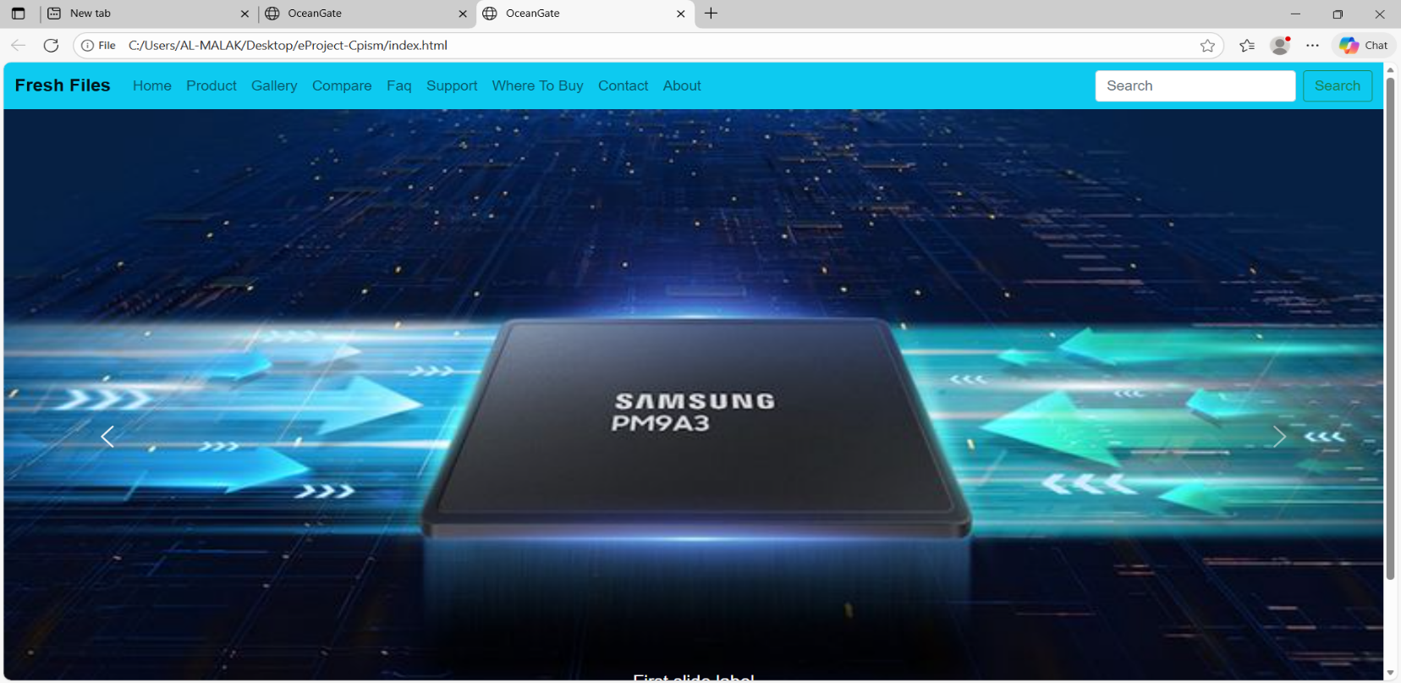

**Gallery SCREENSHOTS**

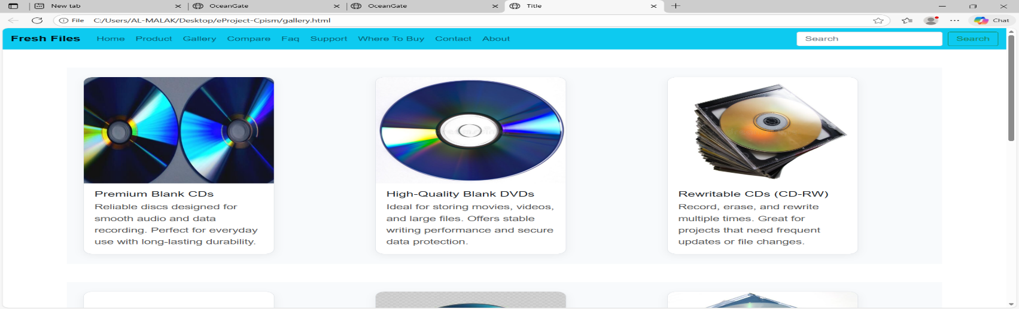

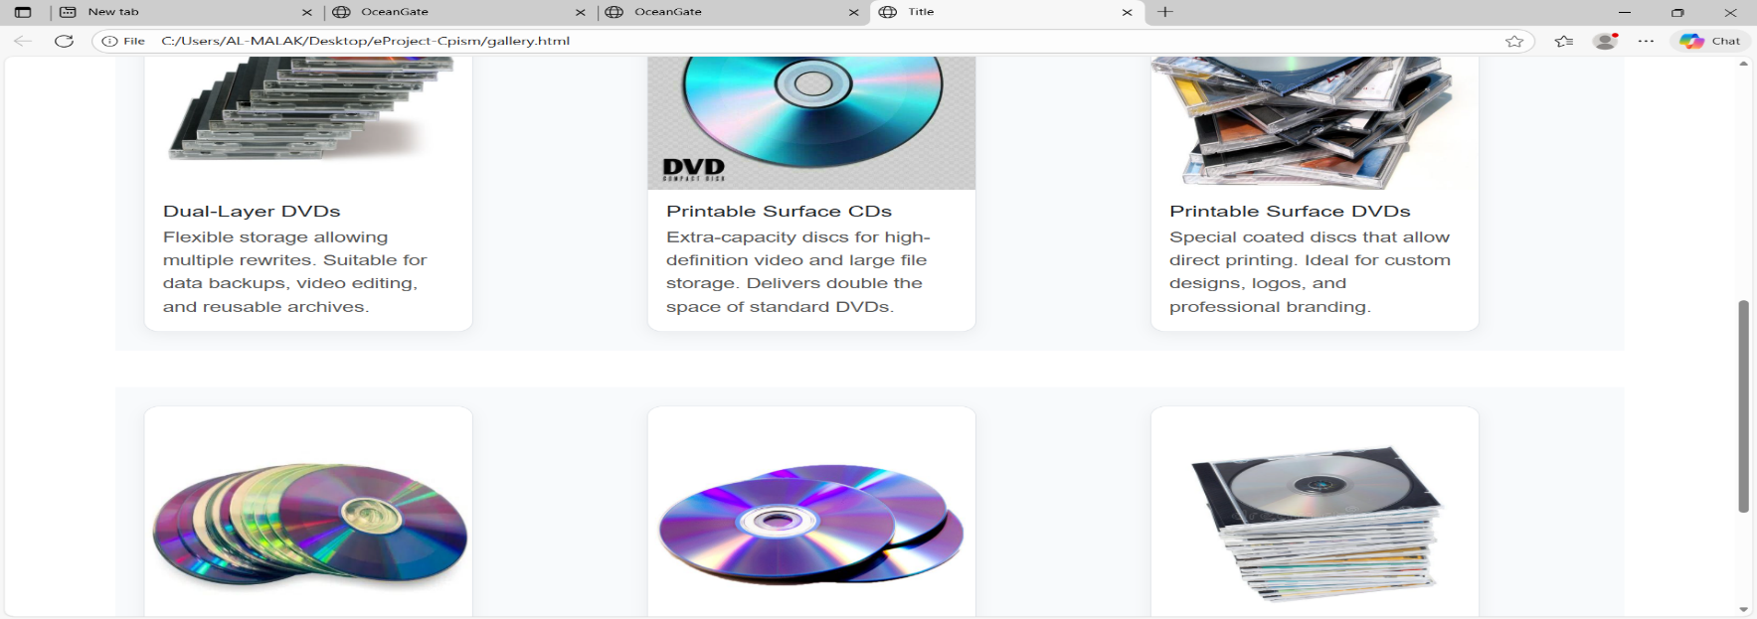

PRODUCT

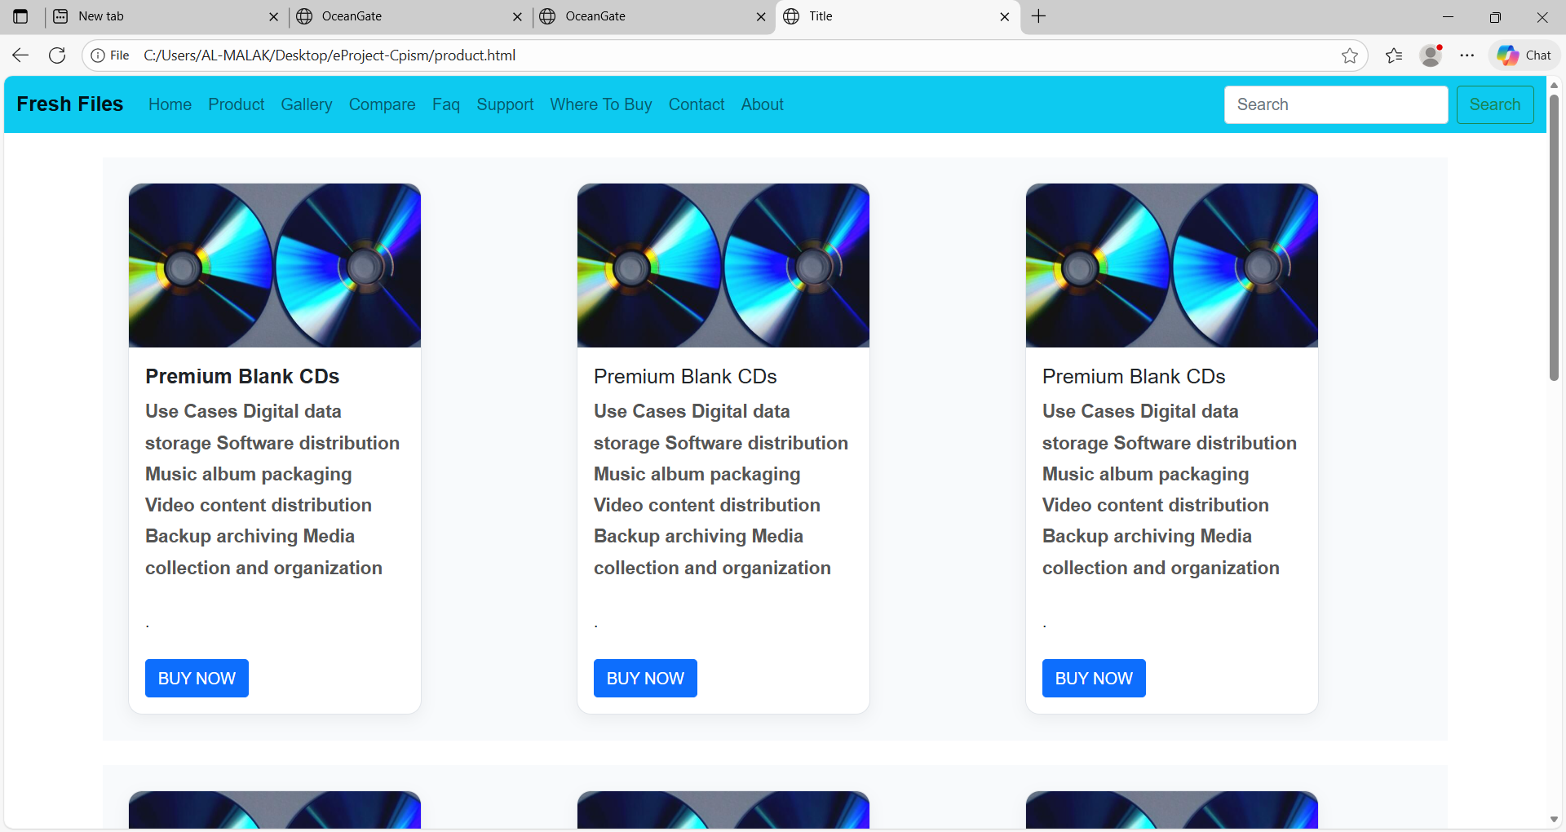

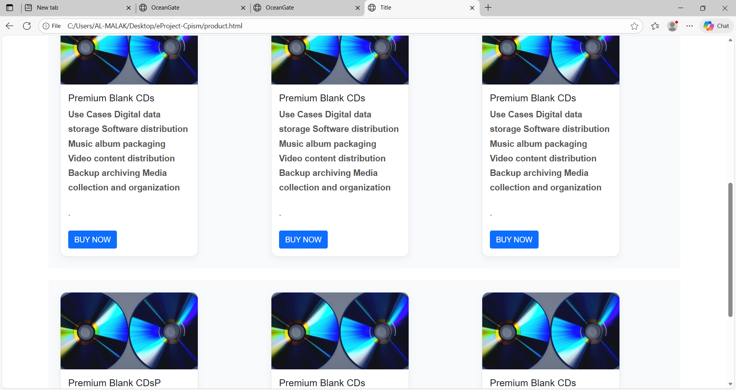

**COMPARE**

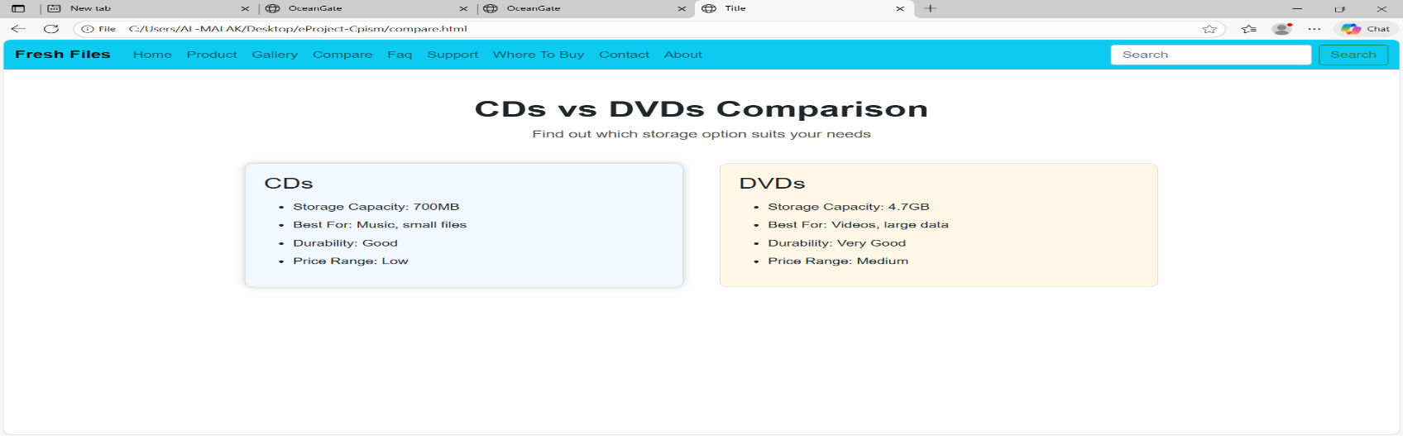

**FAQ’S**

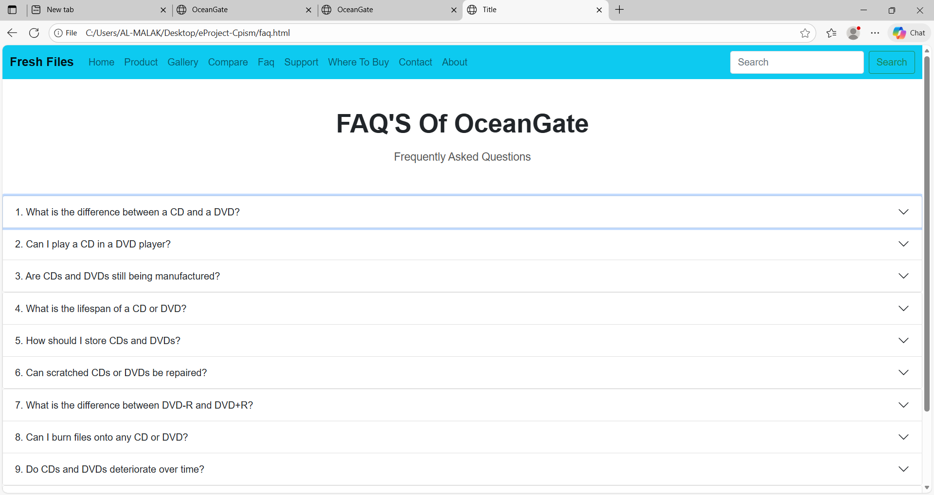

SUPPORT

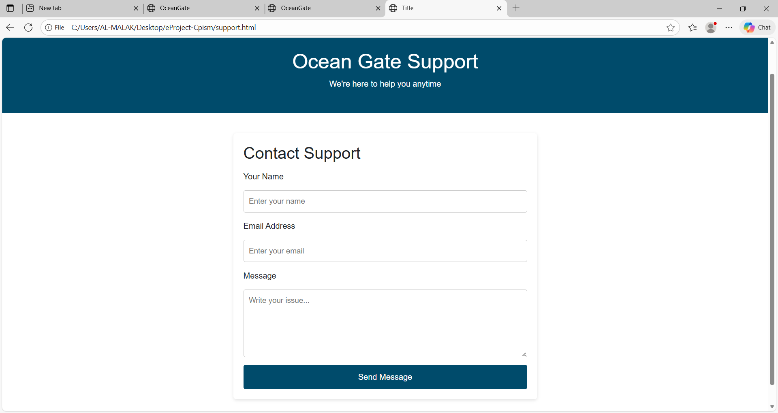

**WHERE TO BUY**

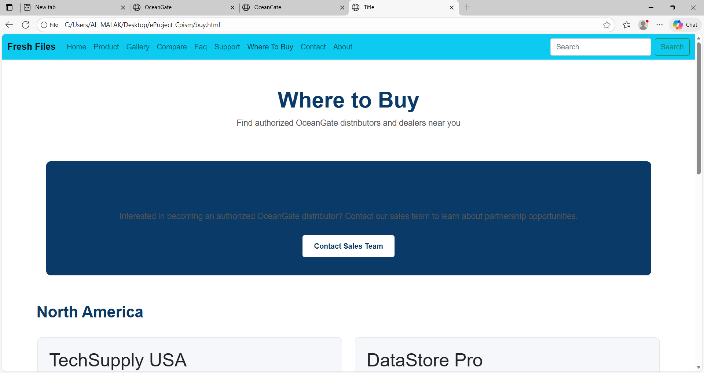

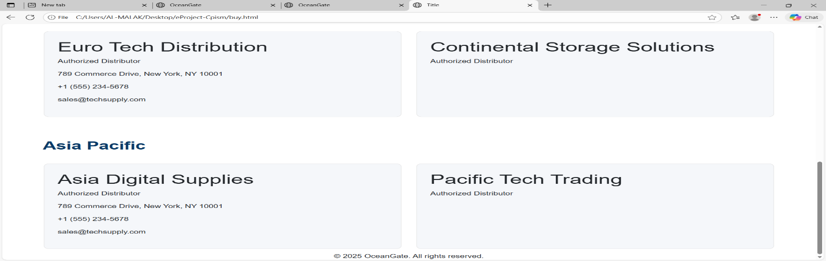

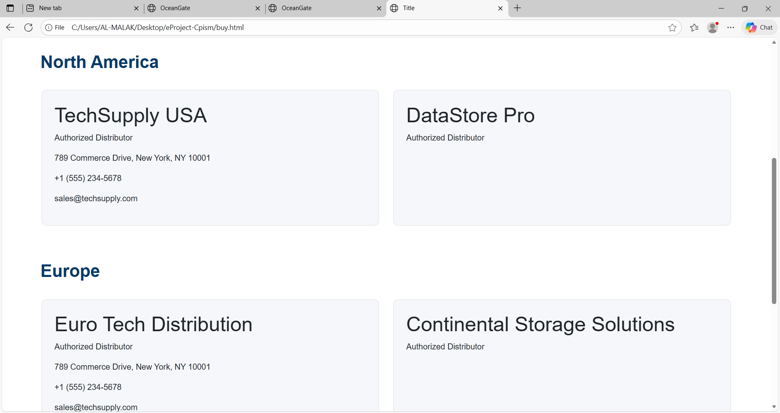

**CONTACT**

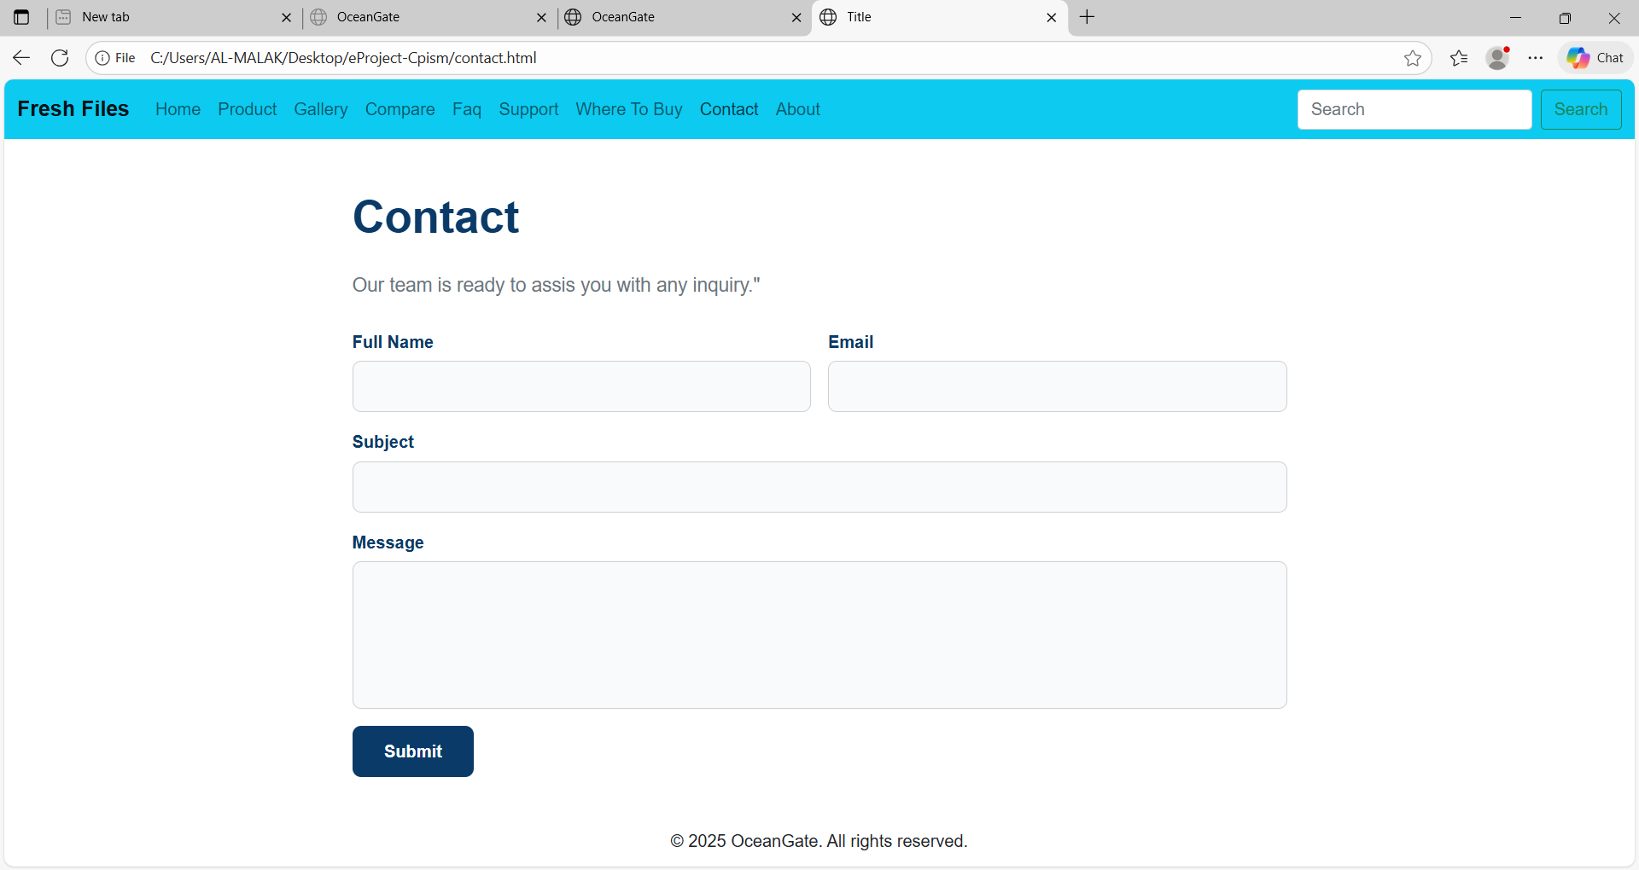

ABOUT

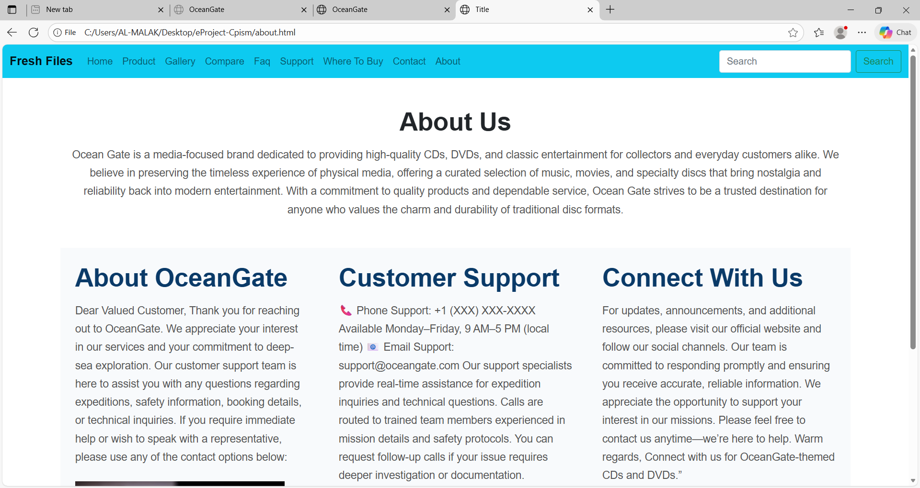

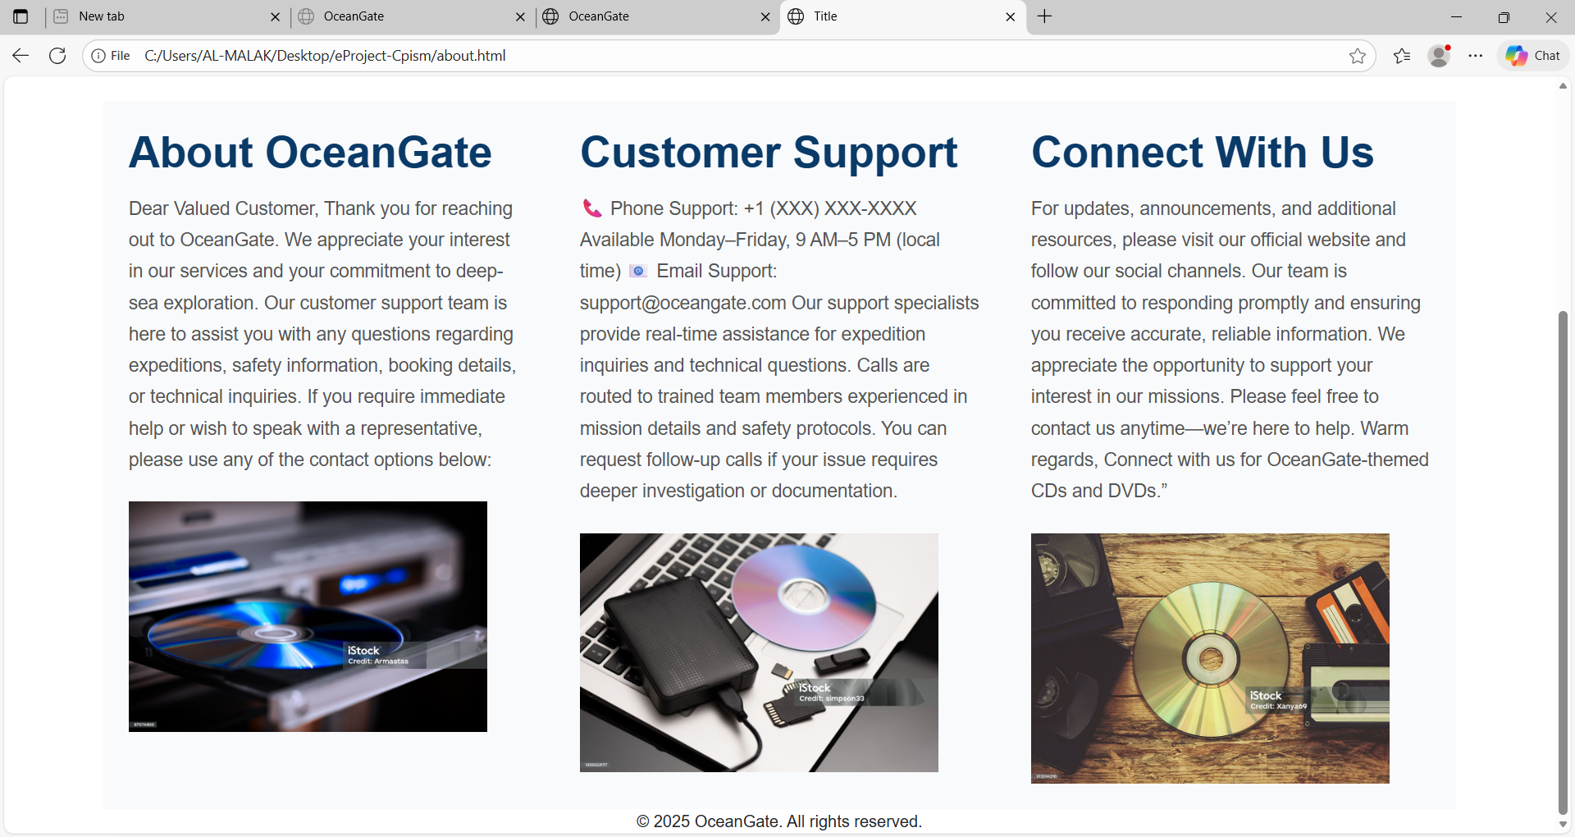

***THANK YOU***